Name : MUHAMMAD MUBASHAR ALI
Student ID : BSIET02213012
Subject : Object Oriented
Lab : 03
Example # 01
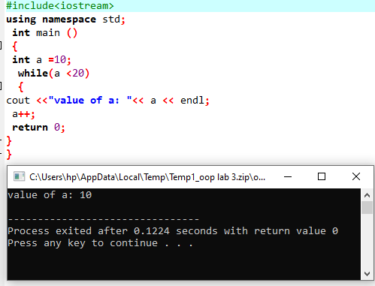
Example # 02
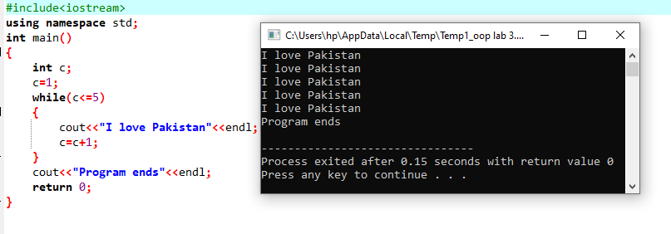
Example # 03
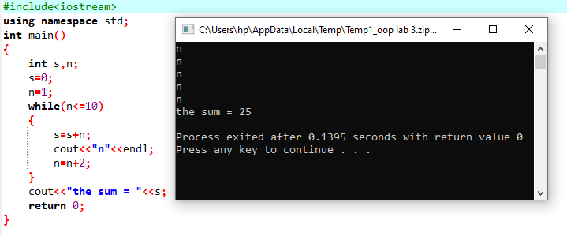
Example # 04
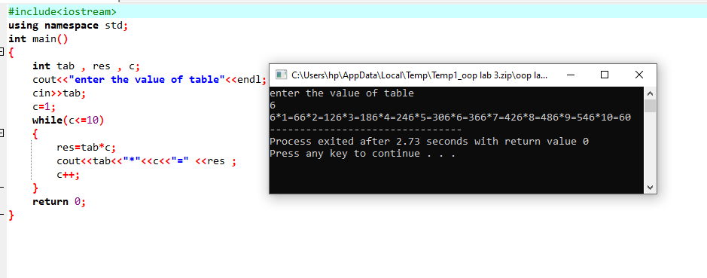

Example # 05
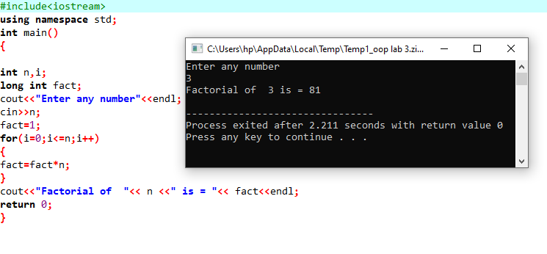
Example # 06
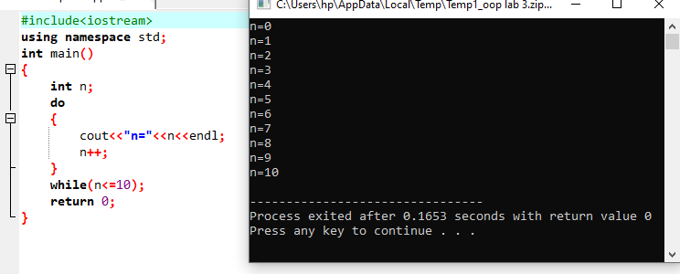

Example # 07
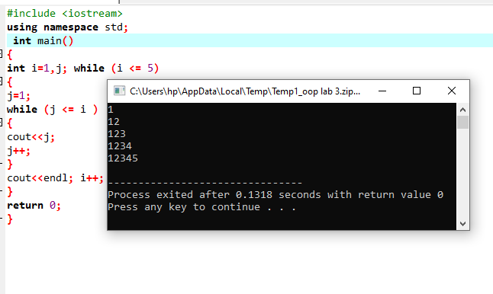
Example # 08
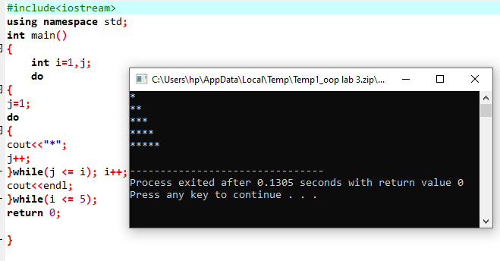

Review Questions
Question # 01
Write a C++ program to find the summation of the following series (using while statement) S=1+ 4 + 9+ 16+………+ (n*n)?
Answer
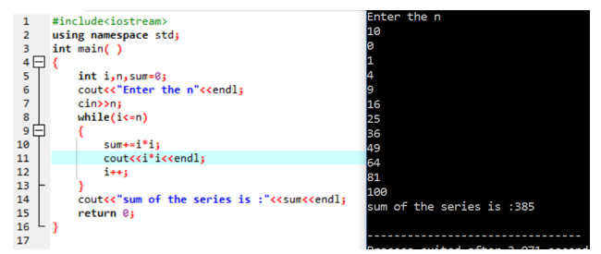

Question # 02
Write a C++ program to print all numbers (that are multiple of 3) from 1 to 100 every 6 numbers on a line.?
Answer
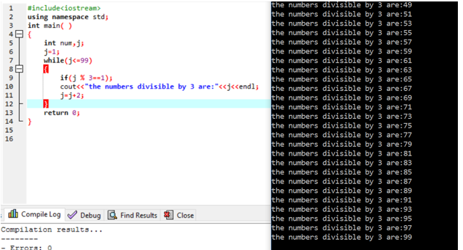

Question # 03
Write a C++ program to find the summation of even digits for any read number from the keyboard (the number could be of any length).?
Answer
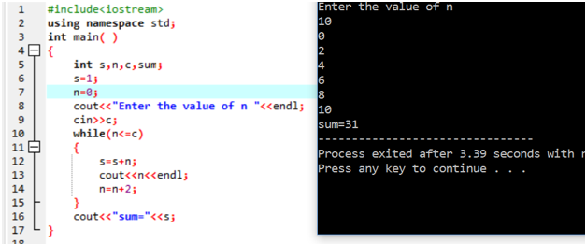

Question # 04
Write a program that computes the sum of the following series using do while loop 1+1/3 +1/5+ 1/7 + + 1/99?
Answer
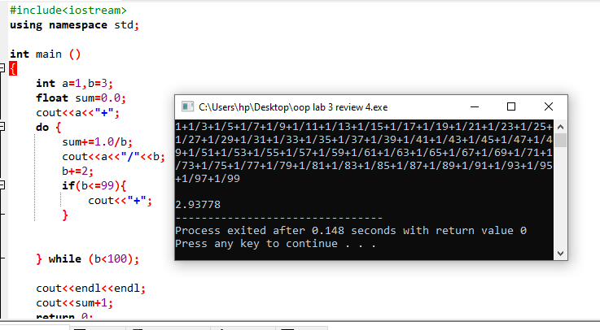

Question # 05
Write a program that displays the output as given under using the nested while loop

1
1 | 4
1 | 4 9
1 | 4 9 16
1 | 4 9 1625

Answer
